

TC TOOL STORAGE CABINETS
ASSEMBLY INSTRUCTIONS
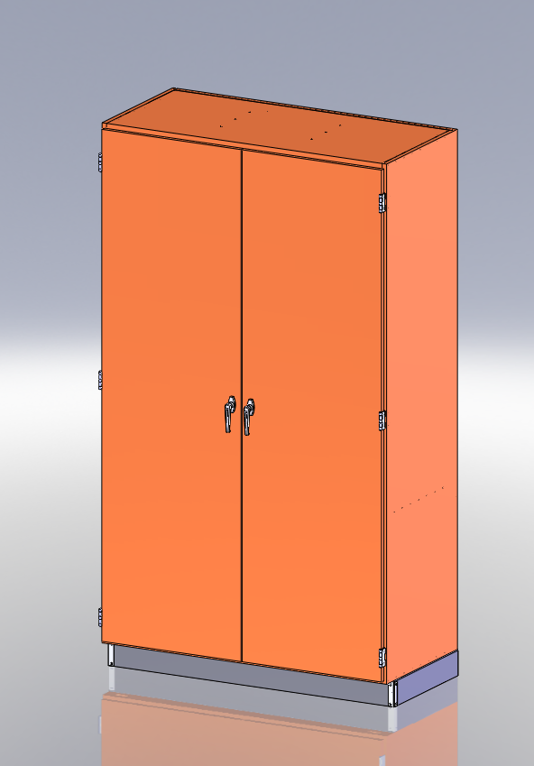
*Model views may not represent exact model purchased
TABLE OF CONTENTS

ASSEMBLY COMPONENTS_______________________________________3
BASE MOLDING________________________________________________4

ASSEMBLY COMPONENTS
ITEMS INCLUDED | PART # |  | PART #
8.66 FT-RUBBER BASE | 100283 | 1-HARDWARE BOX
8-STAINLESS STEEL SCREWS, 6X1/2 | 100064
2-STAINLESS STEEL CORNERS | 100057

REV DESCRIPTION DATE
--- | Original Created | 5-21-09 | NAM

Assembly Instructions for

Storage Cabinets

Tools Needed:
- Contact Cement
- Phillips Head Screwdriver

NOTE!
Cabinet is top heavy and will tip when doors are open if not secured to a wall. Must be fastened to a solid surface prior to assembly of rubber base and shelving

- Following directions on contact cement, apply to back of the three pieces of rubber base and to the base of the cabinet allowing for the appropriate curing time.

- Place the rubber base on cabinet and position the stainless corners on the front two bottom corners of the cabinet and attach with screws provided.

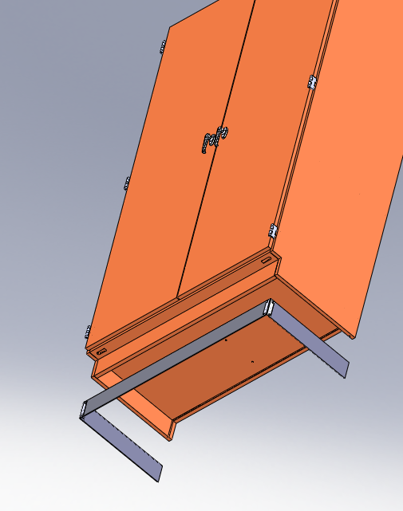

- After cabinet is set in place insert shelf clips in desired locations making sure the shelf is level

